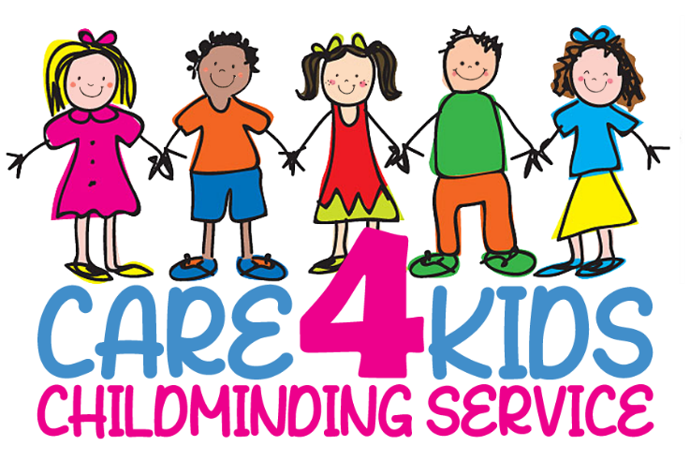
SAFEGUARDING POLICY

1. Statement of Intent
As a registered childminder, I am committed to safeguarding and promoting the welfare of all children in my care. I have a duty to protect children from abuse or neglect and ensure they feel safe, secure, and valued. I will respond promptly and appropriately to any safeguarding concerns and work in partnership with parents, carers, and relevant agencies.

2. Aims
- To provide a safe and secure environment for all children.
- To identify and respond to signs of abuse and neglect.
- To promote children's welfare in line with local and national safeguarding procedures.
- To work with parents and professionals in the best interest of the child.

3. Legal Framework
This policy is based on the following legislation and guidance:
- Children Act 1989 and 2004
- The Childcare Act 2006
- Working Together to Safeguard Children (2018)
- Keeping Children Safe in Education (KCSIE) (2023)
- What to Do If You're Worried a Child Is Being Abused (2015)
- EYFS Statutory Framework (2024)

4. Definitions of Abuse
Abuse is any form of maltreatment. Children may be abused by adults or by other children. The main categories of abuse are:
- Physical abuse
- Emotional abuse
- Sexual abuse
- Neglect

5. Recognising Signs of Abuse
Common signs may include (but are not limited to):
- Unexplained injuries
- Sudden changes in behaviour or regression
- Fear of certain adults
- Poor hygiene or malnutrition
- Sexualised behaviour inappropriate for age
I understand that abuse can also occur online or through child exploitation, including county lines, radicalisation, or female genital mutilation (FGM).

6. Roles and Responsibilities
As the registered childminder, I am the Designated Safeguarding Lead (DSL). My responsibilities include:
- Attending regular safeguarding training (every 2 years minimum)
- Recognising and responding to signs of abuse
- Recording concerns factually and confidentially
- Reporting concerns to the relevant Local Authority Designated Officer (LADO) or Multi-Agency Safeguarding Hub (MASH)
- Liaising with Ofsted if required

7. Procedures for Dealing with Concerns
- Immediate danger: Call 999.
- Non-emergency concern: Contact the Local Safeguarding Team (see contact info below).
- Record the concern: Include time, date, observations, and actions taken. Do not question the child.
- Inform CIW: Report serious incidents or allegations within 14 days.

8. Allegations Against Myself or Household Members
- I will notify CIW immediately (within 14 days) of any allegation made against me or any person living or working in my home.
- I will cooperate fully with LADO investigations and cease childminding activities if directed.

9. Confidentiality
All records are stored securely and shared only on a need-to-know basis, in line with the Data Protection Act 2018 and GDPR.

10. Safer Recruitment and Suitability
All adults in my household aged 16+ have completed an enhanced DBS check. I ensure that no unauthorised adults are left unsupervised with children at any time.

11. Partnership with Parents
I work openly with parents and share this policy during registration. Concerns about a child’s welfare will be discussed with the parent unless doing so puts the child at greater risk.

12. Use of Mobile Phones, Cameras, and Online Safety
- No personal devices are used to take images of children.
- Images (if taken for observation or learning records) are stored securely and deleted when no longer needed.
- Children are supervised when using any technology.

13. Whistleblowing
If I suspect abuse or wrongdoing by another professional, I will report it to:
- LADO or the MASH team
- Ofsted: 0300 123 1231
- NSPCC Whistleblowing Line: 0800 028 0285
- CIW 0300 790 0126

14. Policy Review
This policy is reviewed annually or when changes occur in legislation or guidance.
Date of last review: March 2025
Next review due: March 2026

15. Key Contacts
Service | Contact
Local Safeguarding Children Partnership (LSCP) | 01633 656 656
CIW | 0300 790 0126
Ofsted | 0300 123 1231
Police (non-emergency) | 101
NSPCC Helpline | 0808 800 5000

