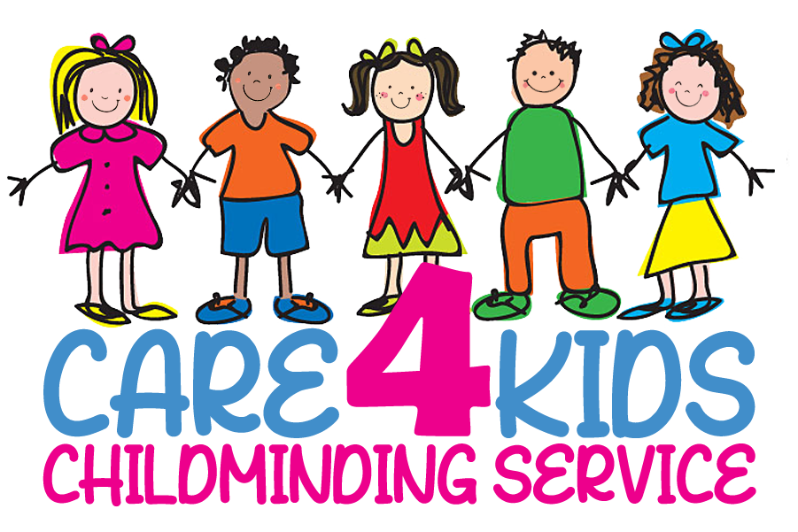
Confidentiality Policy

Any information regarding your child or your family, given to me either verbally or in writing, will be treated as confidential.

All families will receive a copy of all polices and procedures.

Parents will have access to their own child’s records but not to others. All documentation relating to your child is stored in a file, which is not accessible to any other party. This file will be stored in a lockable file in my attic. Any information on my computer will be password protected. Disposal of any information on paper will be shredded. All electronic USBs will be destroyed.

Records about children will be kept for 3 years from the date of the last entry and accident/Incident records will be kept for 21 years.

I will not discuss your child with others unless I have permission from you, for example to take your baby to be weighed by the Health Visitor. I will however divulge confidential information to Social Services and to CSSIW if I have any concerns that your child is being abused. Please see my Child Protection Policy.

No information about any child in my care will be placed on any social media site. As parents you will get to know the other children in my care and at no time are you to comment or share anything publically about any child.

You will also find out confidential information about my family and myself during the course of our working relationship and I would be grateful if you too would respect my family’s confidentiality and not repeat what you may have been told to other parties.

I will comply with the Data Protection Act.

If you have any concerns regarding this policy please do not hesitate to contact me.

