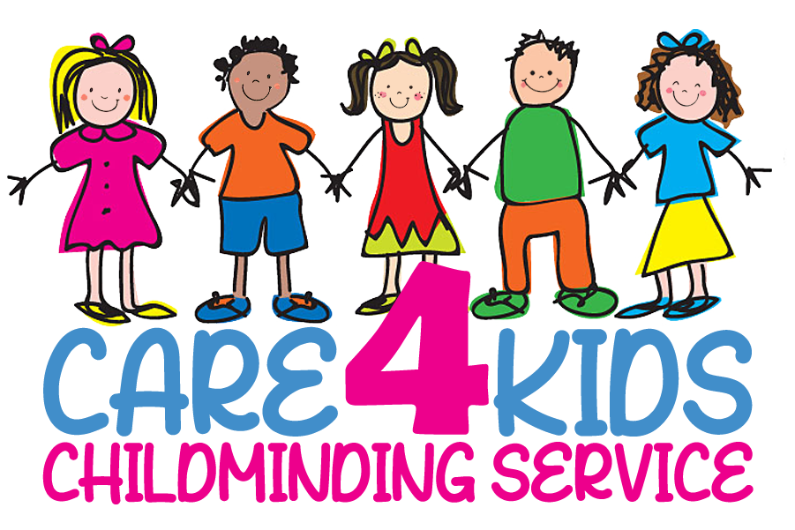
Health and Safety Policy

My house has been inspected by CSSIW and has passed the safety standards which has allowed me to become a registered child minder.

My premises including the outside area are secure and children are not able to leave unsupervised.

I have to adhered to these standards and ensure a safe and secure environment for the children in my house and also when we go out.

I have taken the necessary steps to ensure that all hazards to children on my premises, both inside and outside, are minimized.

A fire blanket is installed in the kitchen.

There are smoke alarms.

I have public liability insurance.

I do not permit smoking in my home.

In order to practice good hygiene, children will be asked to wash their hands before and after eating. Also after they have used the toilet.

My premises, toys and equipment are cleaned regularly.

All food is hygienically stored, prepared and served.

I have attended a first aid course which will be kept up to date. There is a first aid box on my premises which is regularly checked and items replaced as necessary.

