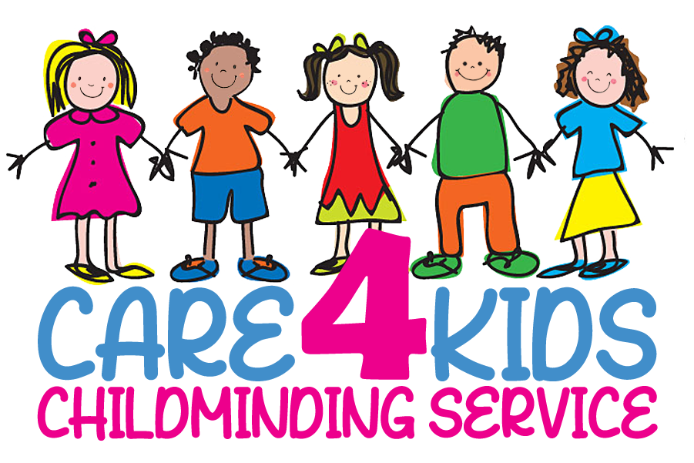
Equal Opportunities Policy

As a Registered Childminder I aim to offer quality childcare, where equal opportunities are practiced. This will be reflected in my daily care, the environment and through communication with the children and parents.

I will make sure that I actively promote equality of opportunity and anti-discriminatory practices for all children. I will make sure that I treat all children with equal concern and respect. I will treat each child as an individual and meet the needs of each child. Help develop a child’s self-identity and to build on their self-esteem and self worth.

My service is open to all children and families in the community.

I will also not discriminate against children on the grounds of disability, sexual orientation, age, class and family status.

I value and respect the different racial origins, religions, cultures and languages in a multi-ethnic society so that each child is valued as an individual without racial or gender stereotyping. I will encourage play from different cultures through cooking, reading and music. I will respect the way of life of each family of the children in my care.

I provide equal chances, opportunities, resources and activities for each child to learn and develop to their full potential, taking into account each child’s age and stage of development, gender, ethnicity, home language, and ability. Promote non-stereotyping play and opportunities and to provide positive images through a range of play activities. Thus reflecting our multicultural society.

I challenge racist and discriminatory remarks, attitudes and behavior from the children in my care and adults. I will always help children to feel good about themselves and others, by celebrating the differences, which make us all unique individuals.
I take into consideration the age and stage of development of each child when purchasing new toys/equipment and when planning activities/outings. I will adapt activities to accommodate the age and stage of development of the children.

I will treat each child as an individual and meet the needs of each child. Help develop a child’s self-identity and to build on their self-esteem and self worth.

All children’s culture and religions will be recorded n my child record forms and this policy will be kept in line with current legislation and I will attend any relevant training.

